**WEEK 2 ASSIGNMENT**

NAME: SANJAY

REGNO: 20BCE0020

1. CREATE,UPDATE,DELETE COMMANDS IN MYSQL

**CREATE**

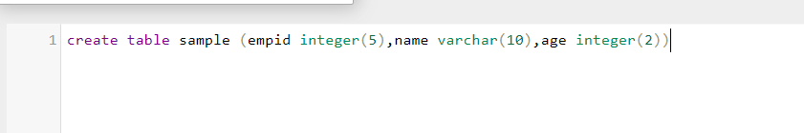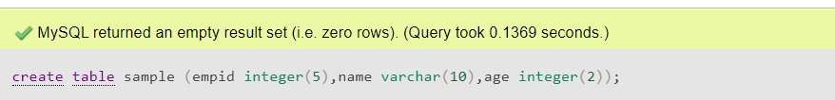

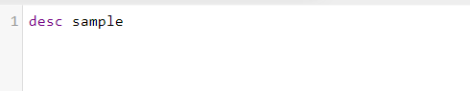

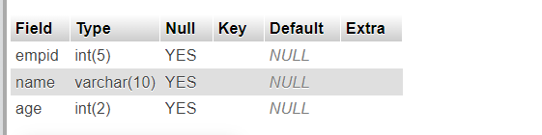

**INSERT**

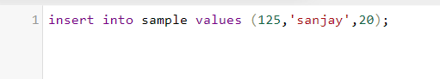

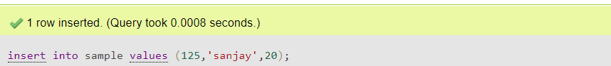

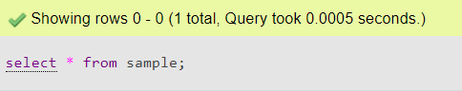

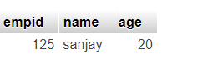

**UPDATE**

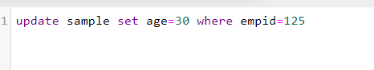

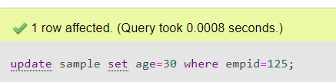

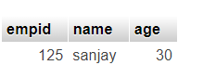

**DELETE**

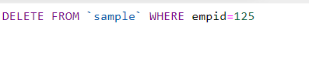

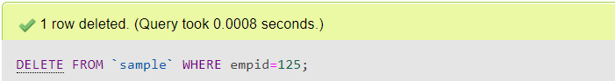

2. JOIN COMMANDS IN MYSQL

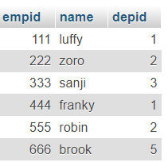 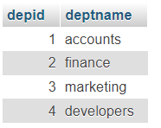

**INNER JOIN**



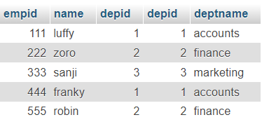

**LEFT JOIN**



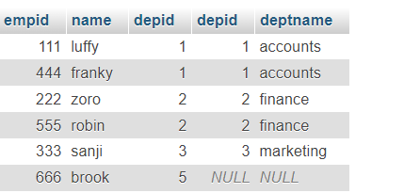

**RIGHT JOIN**



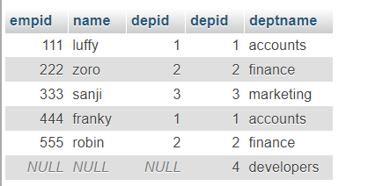

3. CREATE,UPDATE,DELETE COMMANDS IN MONGODB

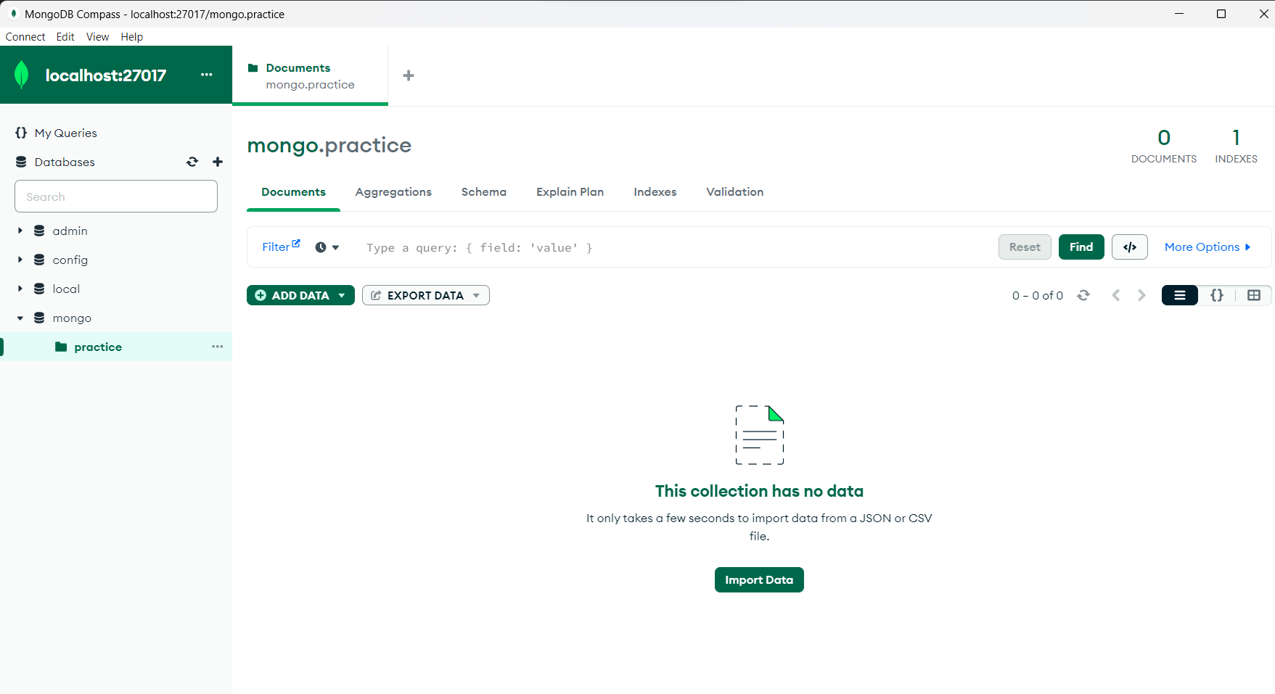

**CREATE**

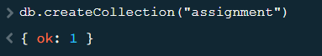

**INSERT**

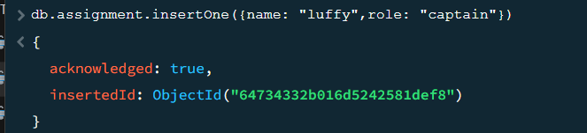

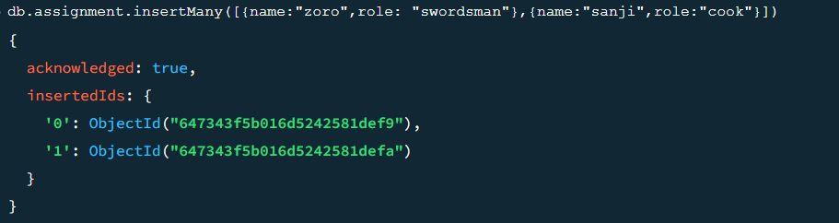

**UPDATE**

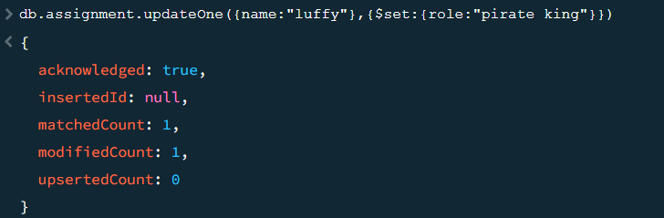

**DELETE**

